CLOUD DATA ENGINEERING
SQL TEST

--Q1. List top 5 customers by total order amount.
--Retrieve the top 5 customers who have spent the most across all sales orders. Show CustomerID, CustomerName, and TotalSpent.

SELECT TOP 5
c.CustomerID,
c.Name,
SUM(so.TotalAmount) AS total_amount
FROM Customer AS c
JOIN SalesOrder AS so
ON c.CustomerID = so.CustomerID
GROUP BY
c.CustomerID,
c.Name;

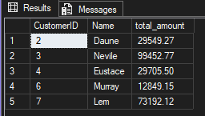

--Q2. Find the number of products supplied by each supplier.
--Display SupplierID, SupplierName, and ProductCount. Only include suppliers that have more than 10 products.

SELECT
s.SupplierID,
s.Name,
COUNT(pod.ProductID) AS product_count
FROM Supplier AS s
JOIN PurchaseOrder AS po
ON s.SupplierID = po.SupplierID
JOIN PurchaseOrderDetail AS pod
ON po.OrderID = pod.OrderID
GROUP BY
s.SupplierID,
s.Name
HAVING COUNT(pod.ProductID) > 10;

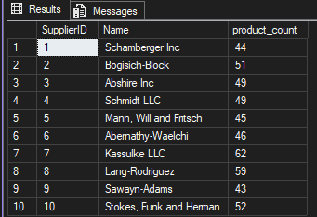

--Q3. Identify products that have been ordered but never returned.
--Show ProductID, ProductName, and total order quantity.

SELECT
p.ProductID,
p.Name,
SUM(sod.Quantity) AS total_order_quantity
FROM Product AS p
JOIN SalesOrderDetail AS sod
ON p.ProductID = sod.ProductID
WHERE p.ProductID NOT IN(
SELECT DISTINCT rd.ProductID
FROM ReturnDetail AS rd
)
GROUP BY
p.ProductID,
p.Name;

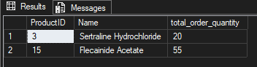

--Q4. For each category, find the most expensive product.
--Display CategoryID, CategoryName, ProductName, and Price. Use a subquery to get the max price per category.

SELECT
c.CategoryID,
c.Name AS CategoryName,
p.Name AS ProductName,
p.Price
FROM Product AS p
JOIN Category AS c ON p.CategoryID = c.CategoryID
WHERE p.Price = (
SELECT MAX(p2.Price)
FROM Product AS p2
WHERE p2.CategoryID = p.CategoryID
)
ORDER BY c.CategoryID;

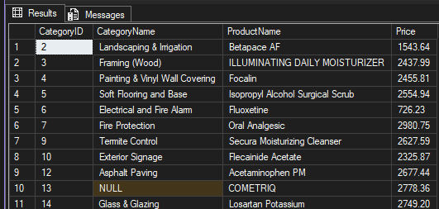

--Q5. List all sales orders with customer name, product name, category, and supplier.
--For each sales order, display:
--OrderID, CustomerName, ProductName, CategoryName, SupplierName, and Quantity.

SELECT
so.OrderID,
c.Name AS CustomerName,
p.Name AS ProductName,
cat.Name AS CategoryName,
s.Name AS SupplierName,
sod.Quantity
FROM SalesOrder AS so
JOIN Customer AS c ON so.CustomerID = c.CustomerID
JOIN SalesOrderDetail AS sod ON so.OrderID = sod.OrderID
JOIN Product AS p ON sod.ProductID = p.ProductID
JOIN Category AS cat ON p.CategoryID = cat.CategoryID
JOIN Supplier AS s ON s.SupplierID = s.SupplierID;

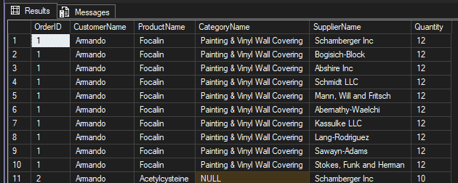

--Q6. Find all shipments with details of warehouse, manager, and products shipped.
--Display:
--ShipmentID, WarehouseName, ManagerName, ProductName, QuantityShipped, and TrackingNumber.

SELECT
sh.ShipmentID,
w.Name AS WarehouseName,
emp.Name AS ManagerName,
p.Name AS ProductName,
sd.QuantityShipped,
sh.TrackingNumber
FROM Shipment AS sh
JOIN Warehouse AS w ON sh.WarehouseID = w.WarehouseID
LEFT JOIN Employee AS emp ON w.ManagerID = emp.EmployeeID
JOIN ShipmentDetail AS sd ON sh.ShipmentID = sd.ShipmentID
JOIN Product AS p ON sd.ProductID = p.ProductID;

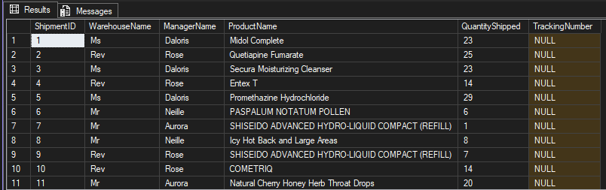

--Q7. Find the top 3 highest-value orders per customer using RANK().
-- Display CustomerID, CustomerName, OrderID, and TotalAmount.

WITH RankedOrders AS (
SELECT
c.CustomerID,
c.Name AS CustomerName,
so.OrderID,
so.TotalAmount,
RANK() OVER(PARTITION BY c.CustomerID ORDER BY so.TotalAmount DESC) as OrderRank
FROM Customer AS c
JOIN SalesOrder AS so ON c.CustomerID = so.CustomerID
)
SELECT
CustomerID,
CustomerName,
OrderID,
TotalAmount
FROM RankedOrders
WHERE OrderRank <= 3;

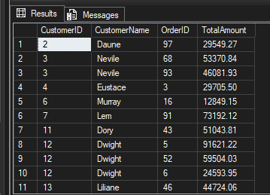

--Q8. For each product, show its sales history with the previous and next sales quantities (based on order date). Display ProductID, ProductName, OrderID, OrderDate, Quantity, PrevQuantity, and NextQuantity.

SELECT
p.ProductID,
p.Name AS ProductName,
so.OrderID,
so.OrderDate,
sod.Quantity,
LAG(sod.Quantity) OVER(PARTITION BY p.ProductID ORDER BY so.OrderDate) AS PrevQuantity,
LEAD(sod.Quantity) OVER(PARTITION BY p.ProductID ORDER BY so.OrderDate) AS NextQuantity
FROM Product AS p
JOIN SalesOrderDetail AS sod ON p.ProductID = sod.ProductID
JOIN SalesOrder AS so ON sod.OrderID = so.OrderID;

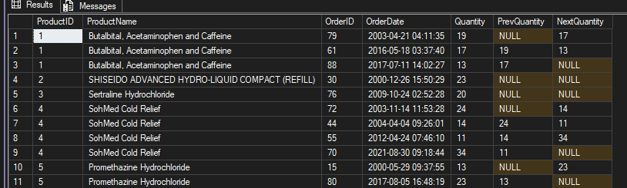

--Q9. Create a view named vw_CustomerOrderSummary that shows for each customer:
--CustomerID, CustomerName, TotalOrders, TotalAmountSpent, and LastOrderDate.

CREATE VIEW vw_CustomerOrderSummary AS
SELECT
c.CustomerID,
c.Name AS CustomerName,
COUNT(so.OrderID) AS TotalOrders,
SUM(so.TotalAmount) AS TotalAmountSpent,
MAX(so.OrderDate) AS LastOrderDate
FROM Customer AS c
LEFT JOIN SalesOrder AS so ON c.CustomerID = so.CustomerID
GROUP BY
c.CustomerID,
c.Name;

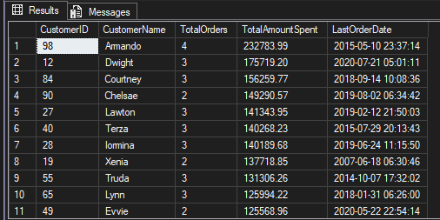

--Q10. Write a stored procedure sp_GetSupplierSales that takes a SupplierID as input and returns the total sales amount for all products supplied by that supplier.

CREATE PROCEDURE sp_GetSupplierSales
@SupplierID INT
AS
BEGIN
SET NOCOUNT ON;

SELECT
s.SupplierID,
s.Name AS SupplierName,
ISNULL(SUM(sod.Quantity * sod.UnitPrice), 0) AS TotalSalesAmount
FROM Supplier AS s
JOIN Product AS p ON s.SupplierID = p.SupplierID
JOIN SalesOrderDetail AS sod ON p.ProductID = sod.ProductID
WHERE s.SupplierID = @SupplierID
GROUP BY s.SupplierID, s.Name;
END;
